Ques 5: Configure liveliness and readiness probes for pods in AKS cluster.

SOLN :

What are Probes in Kubernetes?
Probe Type | Purpose
Liveness Probe | Checks if the container is alive. If it fails, the container is restarted.
Readiness Probe | Checks if the container is ready to serve traffic. If it fails, it’s removed from Service endpoints.
Used together, they help AKS maintain high availability and reliability of applications

Step-by-Step: Configure Probes in Deployment

Below is an example YAML for a pod with both liveness and readiness probes configured:

we are creating a new deployment for testing the same :

Save the above YAML as probes-deployment.yaml
- Run:
kubectl apply -f probes-deployment.yaml
Check status:

kubectl get pods
kubectl describe pod <your-pod-name>

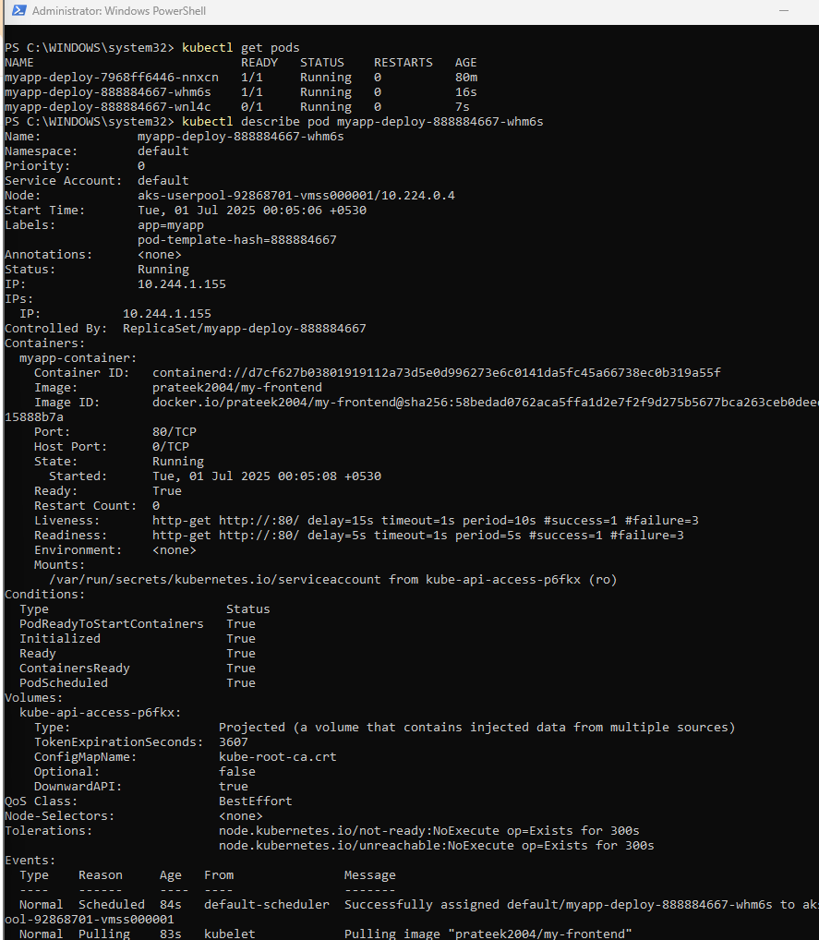

Probe Status:
- Liveness: http-get http://:80/ → Passing
- Readiness: http-get http://:80/ → Passing
- Ready: True
- Restart Count: 0

This confirms:
- Pod is stable
- Health checks are configured correctly
- No crashes or restarts due to failed probes
I configured HTTP-based liveness and readiness probes for the frontend container in my AKS deployment. Initially, the probes were failing because they pointed to non-existent paths (/healthz and /ready). I identified that the application serves content on the root path (/), and updated the probe paths accordingly.
After applying the updated deployment configuration, both probes started succeeding. The pod transitioned to Ready: True and stayed stable with no restarts. This demonstrates successful health check configuration using Kubernetes probes to monitor application availability and startup readiness.

Problem in Real Life:
Imagine you're running a real website (like Flipkart, Tabcura, etc.) inside Kubernetes. What if:
- 🔁 The app crashes or gets stuck (e.g., due to a memory leak)?
- 🕓 The app is slow to start, but Kubernetes thinks it’s ready?
- 🧑‍💻 A deployment rollout happens, but some pods aren’t actually ready to serve traffic?

✅ Here's Where Probes Help

1. Liveness Probe: Are you alive?
- 💡 Use Case: If the app gets stuck or hangs due to bugs, Kubernetes will kill and restart the container automatically.
- 🔥 Real-world example: A microservice in Amazon app stuck in a loop — Kubernetes detects it's "unhealthy" and restarts it.

2. Readiness Probe: Are you ready to serve traffic?
- 💡 Use Case: Sometimes, the container is running but not ready to take requests (e.g., loading config, initializing DB).
- 🧠 **Kubernetes will wait before sending traffic to it. If it fails later, traffic is routed away.
- 🔥 Real-world example: A payment service is still connecting to Razorpay APIs — Kubernetes won’t send users’ payments there until it's ready.

So we can say that Real-World Use Case:
In production environments, readiness and liveness probes help maintain app availability and reliability.
- If a pod is not ready, Kubernetes avoids sending user traffic to it — improving user experience.
- If the app is stuck or unhealthy, the liveness probe helps Kubernetes self-heal by restarting it.
This ensures zero downtime, smoother rollouts, and better handling of unexpected failures — which is critical in real-time systems like e-commerce, healthcare, and financial apps.

Let's simulate a failed liveness probe — to understand how Kubernetes self-heals unhealthy pods.

What We'll Do:
We will intentionally fail the liveness probe by pointing it to a non-existing path (e.g., /failcheck). Kubernetes will keep checking this path, get a 404, and restart the pod after 3 failed attempts.

1. Modify Your Deployment YAML
Change the liveness probe like this:
livenessProbe:
httpGet:
path: /failcheck # This path does NOT exist in your app
port: 80
initialDelaySeconds: 5
periodSeconds: 5
failureThreshold: 3

kubectl apply -f liveness-fail.yaml
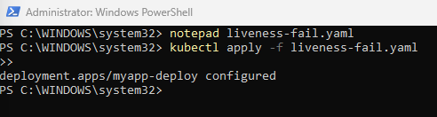
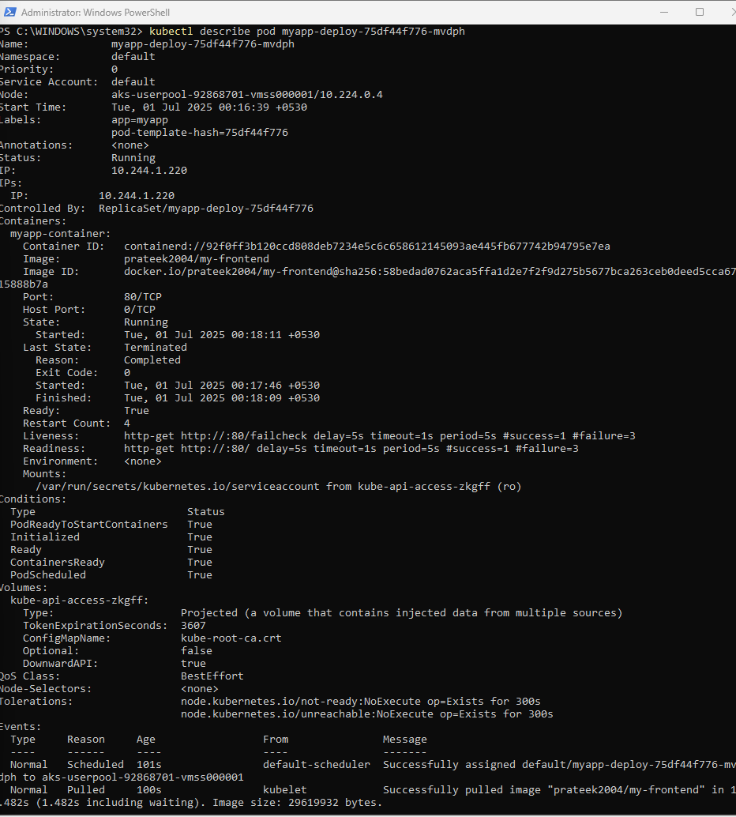
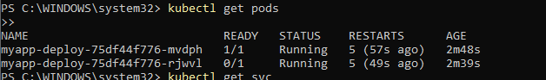

What's Happening:
- myapp-deploy-75df44f776-mvdph
  - Status: Running but READY 0/1 → not passing probes.
  - Restart count is 1 → it already failed the liveness probe once and got restarted.
- myapp-deploy-75df44f776-rjwvl
  - Status: Running and READY 1/1 → this pod is healthy and passing probes.

Conclusion:
- Your failing liveness probe simulation is working!
- Kubernetes detected /failcheck doesn't exist (likely returned HTTP 404), so it restarted the unhealthy pod — showcasing self-healing in AKS.

Hence As an additional effort, I configured a failing liveness probe (/failcheck) on one of the pods. Kubernetes detected the failure through the liveness probe and restarted the unhealthy container automatically. This demonstrates Kubernetes' built-in self-healing mechanism, which ensures the application remains highly available and resilient even if individual pods become unresponsive or unhealthy.

